41.28: a) 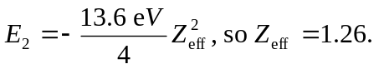b) Similarly, 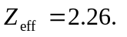c) 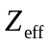 becomes larger going down the columns in the periodic table.

